**Designing of Free Space Optical Communication Network under Different Weather Conditions**

Hardeepak Singh1, Vishal Kumar1, Vivek Takhi2, Simranjit Singh2 and Amardeep Singh1

1Department of Computer Engineering, Punjabi university, Patiala, Punjab, India

2Department of Electronics and Communication Engineering, Punjabi university, Patiala, Punjab, India

**Abstract**

Free Space Optical (FSO) communications, also known as Free Space Photonics (FSP) or Optical Wireless, concerns to the transmission of visible or infrared (IR) beams through the atmosphere to obtain optical communications. During this course of work, the designing of FSO network is totally depends upon the atmospheric attenuation. Different weather conditions have different attenuations, which causes signal degradation on the basis of scattering, visibility etc. A rain season shows the maximum attenuation, in which beam of signal scattered due to the raindrops. In this work, the FSO communication network is proposed using network different topologies between the two cities. During this course of work, the region of Patiala and Rajpura, Punjab, India has been taken and investigated network’s performance under different weather seasons. This work has been designed to adhere the eventuality of FSO communication in the proposed network with the wavelength of 1550 nm onwards. In this paper, the two ring networks are designed in the two cities respectively, which are also connected with free space optical channel with relative line of sight distance. The simulation results have been adhered by anatomizing the bit error rate and Quality factor with power alteration according to weather conditions. During this work, an optical amplifiers/repeaters have been used in certain weather conditions to achieve the acceptable results at each node.

1. **Introduction**

Long distance transmission and high data rate is the obligation in the optical communication which leads to improvements that can dispose of the need for costly alterations from optical to electrical signal and vice versa [1]. In Free space optical (FSO) communication, free space is used as medium for transfer information of an optical carrier. In recent past, FSO communication has recently exert influenced large scale interest within the investigation community, since it can be auspicious for number of applications [2]. FSO communication free of licensing, because operates at very high frequency. FSO communication is a line-of-sight (LOS) technology, which is operating the optical communications with 1st, 2nd and 3rd transmission windows respectively at wavelengths of 850nm, 1300 nm and 1550nm. These wavelengths of transmission windows have attenuation less than 0.2dB/km, which can use the same commercial components of an optical fiber [3]. The adherence and individuality of the link is highly atmospheric factors dependent such as rain, fog, dust, smog and heat. FSO components are embracing three stages: transmitter to broadcast an optical radiation over the atmosphere, free space transmission channel where the turbulent odd factors like cloud, rain, smoke, gases, temperature variations, fog and aerosol exists and receiver to process the received signal [4]. Larger bandwidth, higher gain of antenna, better privacy/security, smaller antenna and component sizes, and lower component costs are the advantages of FSO communication systems. Due to these advantages, FSO has been widely used in applications like space communications, temporary installations of network, safety add-on for important fiber connections, aircraft-to-aircraft communications, the last-mile access, and military applications [5]. In order to enhance the performance of FSO systems, various techniques of generation are used. These techniques are known as the Optical Code Division Multiple Access based Spectral Amplitude Coding system (OCDMA Based SAC System), High Speed Long Reach OFDM (Orthogonal Frequency Division Multiplexing) Schemes based systems and WDM scheme based System [6]. In FSO communication, medium of the transmission-receiving is an atmosphere and there are some un-ignorable environmental challenges. The most of the atmospheric phenomenon like scintillation, geometric losses, absorption, atmospheric turbulence, atmospheric attenuation, scattering [7] and attenuation due to weather conditions of atmosphere [8]. Several considerations have been supervised on the different weather of different regions and the existence of beam wander has been investigated by correlating bit error ratio with beam width [9]. In terrestrial region, the optical link attenuation measurements results have been performed experimentally for visibilities ranging from 9-12 km. With operating wavelength of 780nm a visibility and attenuation have been calculated over a distance for a FSO link [10].

In Canada region, different sorts of modulations have been studied to resolve the rain attenuation effect on FSO performance. It was realized that as compared to the low rain rate, the signal-to-noise ratio (SNR) and bit-error rate (BER) has been severely degraded in the results with a high rain rate [11].

In Changsha, China region, point to one point (P2OP) FSO communication has been established in heavy rain weather. Further it was realized that the potentiality of communication links with bit rate up to 1.5 Gbps is up to 3 km with WDM spectrum slicing (SS) technique in heavy rain season [12]. During this course of work, point-to-multi-point (P2MP) communication in a hybrid topology based network with data rate up to 5 Gbps/channel with the acceptable results has been investigated. The results at every node of the network have been observed for all weather conditions. The attenuation factors with the time duration of weather seasons are described in Table 1. From This table, it has been adhered that the rainy season shows the maximum attenuation throughout all seasons. It can upgrade the system capacity to achieve high speed network facilities. FSO will functions properly with using the optical repeaters after an appropriate transmission distance.

The paper is organized into four sections. Introduction section describes the overview and working principle in which gaps with the aim and previous studies have been discussed. In Section 2, we have explained the working of proposed hybrid topology network. In section 3, the results and discussions have been described. Finally, conclusions and future work are made in Section 4.

Table 1: Seasonal details with respective attenuation.

|  |  |  |
| --- | --- | --- |
| **Weather Season** | **Time Duration** | **Attenuation (dB/km)** [6] |
| Clear Season | March to Last June | 0.23 |
| Rain Season | July to September & September to October | 9.64 |
| Fog Season | December to February | 2.37 |

1. **Proposed Hybrid Topology Network**

In this network, different optical source has been used for the generation of each input signal. An optical multiplexer and de-multiplexer have been used according to their application of combining and for slicing the signal to the number of channels with their wavelengths and at the receiver end, photo-detector has been used [13]. In literature, in WDM technology, the optical transmission spectrum is distributed into a number of different frequency/wavelength bands, with a single wavelength communication channel operating at desired rate. In optical communication system, WDM is a technology in which bidirectional communications is used over fiber and capacity multiplication [14]. In this present piece of work, for the implementation of a bit stream of 5 Gbps data rate per channel, NRZ modulation format with Pseudo code generator has been used. Further, with the channel spacing of 0.5 nm the twelve multiplexed signals are transmitted over a FSO channel in the rings and fifteen signals are transmitted over a high speed link between two rings.

The proposed hybrid network architecture is shown in the Fig.1. The 12 channels of different wavelengths which start from 1550nm have been generated using the 12-continuous wave (CW) laser sources. At each node, 9 channels have been dropped out and the rest 3 channels have been used for the transmission between other nodes. According to the weather conditions, the input power of CW laser has been set like 20 dBm for a Clear season, 30 dBm for foggy season and 40 dBm for the rainy season. The Mach-zehnder Modulator has been used to modulate the optical signals. The 12:1 multiplexer has been used to multiplex/combine the channels for the transmission over a single channel. Then the modulated signal has been transmitted over an FSO network with 11 nodes spreading over different lengths. The architecture of transmitter and receiver is shown in Fig.2.

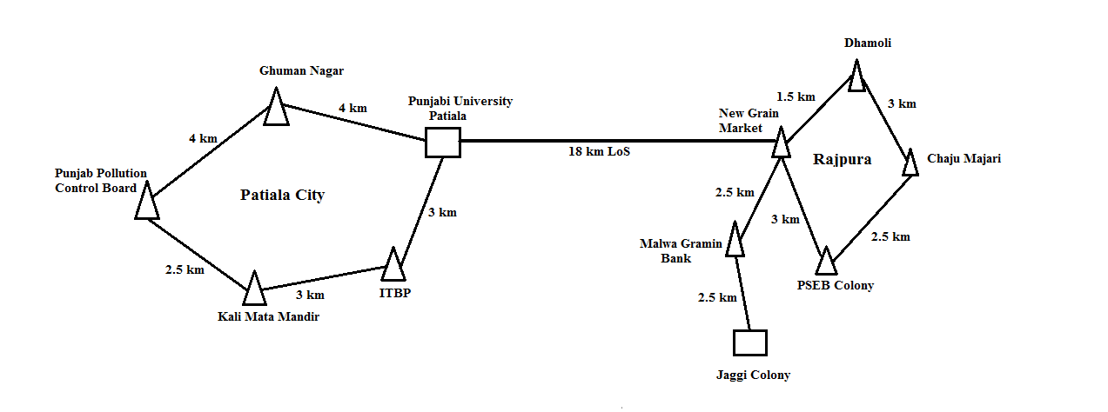

**Fig. 1.** Architecture of FSO network.

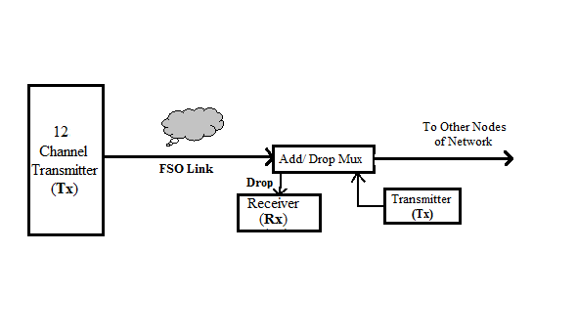

**Fig. 2.** Architecture of transmitter and receiver.

The different parameters of FSO channel which are used in simulation has been explained in Table 2. In FSO channels, the propagation distance between transmitter and receiver end is defined by Range parameter.

Table 2: Parameters of FSO channel.

|  |  |
| --- | --- |
| **Parameters** | **Range** |
| Input power | Clear weather: 20 dB  Foggy weather: 30 dB  Rainy weather: 40 dB |
| Wavelength | 1550 nm onwards (12 channels with equal channel spacing of 0.5 nm and 15 channels for high speed link between two rings) |
| Bit Rate | 5 Gbps |
| Transmitting Distance | Punjabi University to Ghuman Nagar: 4 km  Ghuman Nagar to Punjab Pollution Control Board: 4 km  Punjab Pollution Control Board to Kali Mata Mandir : 2.5 km  Kali Mata Mandir to ITBP: 3 km  ITBP to Punjabi University: 3 km  Punjabi University to New Grain Market Rajpura : 18 km  New Grain Market to Dhamoli : 1.5 km  Dhamoli to Chaju Majari : 3 km  Chaju Majari to PSEB Colony : 2.5 km  PSEB Colony to New Grain Market : 3 km  New Grain Market to Malwa Gramin Bank : 2.5 km  Malwa Gramin Bank to Jaggi Colony : 2.5 km |
| Extinction Ratio | 30 dB |
| Attenuation | Varying (According To Weather condition defined in Table 1) |
| Transmitter Aperture Diameter | 5 cm |
| Receiver Aperture Diameter | 20 cm |
| Beam Divergence | 2 mrad |

An optical add-drop multiplexer (OADM) has been used to receive a signal from drop port and it will transmit another signal from add port at each node of ring network. Very high attenuation (9.67 dB/km) has been observed in case of the rainy season, which leads the unacceptable performance. Hence, for the acceptable performance and continous working of network, the repeaters are needed after every 1 km of transmission distance. On the receiver end, with tuning the filter to desired wavelength, any signal from twelve channels can be received at every node of the network. At the receiving end of every node, for the conversion of an optical signal to electrical signal, the PIN/Avalanche photo-detector has been used.

1. **Results and discussions**

In this paper, the Optisystem simulation software of Optiwave has been used to carry out simulations. The result representations have been described that the proposed hybrid network is performing well and it is suitable for FSO communication with bit rate of 5 Gbps during all seasons. The Fig. 3 shows the variations of Q factor with respect to the used wavelengths at each node for clear season, in which the Node 1(4 km) has high Q factor than other node. The reason behind it is that this node is the first transmitting node in the network. The average variation of Q-factor has been shown by Node 2(2.5 km), Node 3(3 km), Node 5(18 km) and Node 11(2.5 km) as compared to the rest nodes. The rest nodes Node 4(3 km), Node 6(1.5 km), Node 7(3 km), Node 8(2.5 km), Node 9(3 km) and Node 10(2.5 km) shows the minimum Q-factor then other nodes. Fig.4 shows the output eye diagram of each node of the designed network.

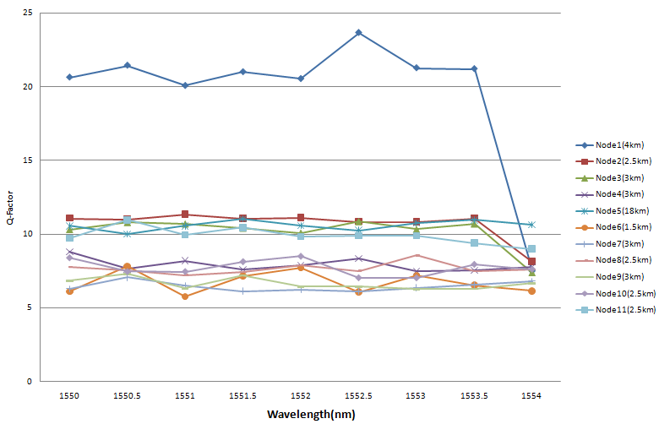**Fig. 3.** Graph of variation of Q factor with respect to the used wavelengths at each node for clear season.

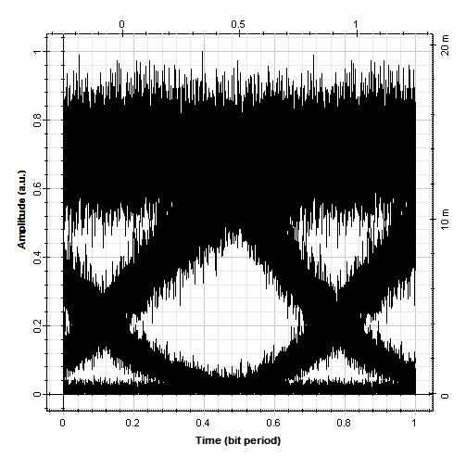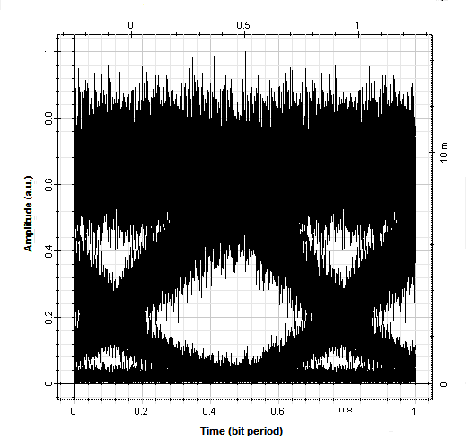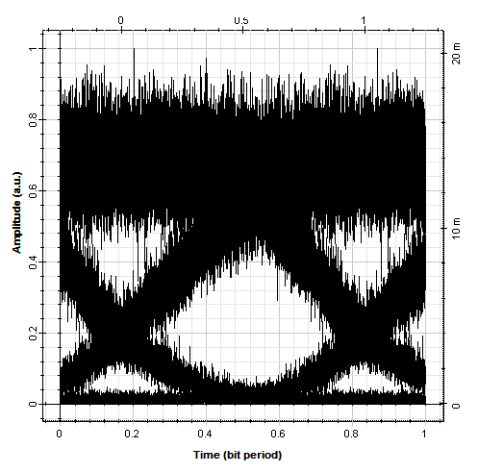

1. (b) (c)

**Fig.4**. The received output eye diagrams at different nodes for clear season.

The Fig. 5 describes the variation in Q-Factor with wavelength for foggy season. Node 1(4 km) and Node 11(2.5km) have high Q-Factor as compared to other nodes, because these nodes are the starting and last nodes of the proposed network. The attenuation factor in the foggy season is average than these two other seasons. The rest of the nodes show the greater Q-factor then the acceptable value. The output received eye diagrams of every node have been described in the Eye diagrams Fig. 6.

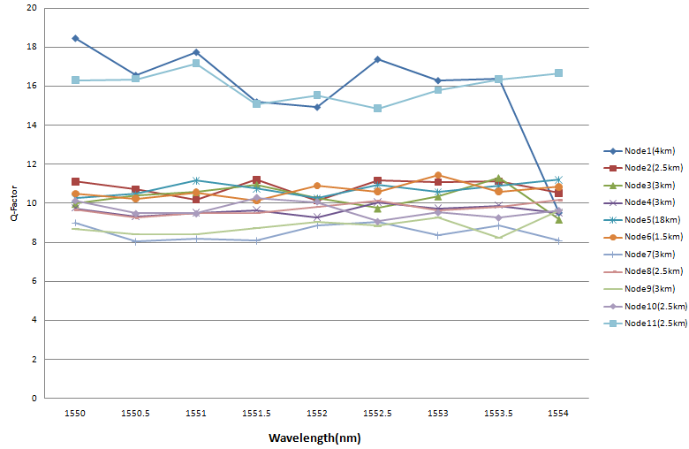**Fig.5.** Graph of Q factor with respect to the used wavelengths at each node for foggy season.

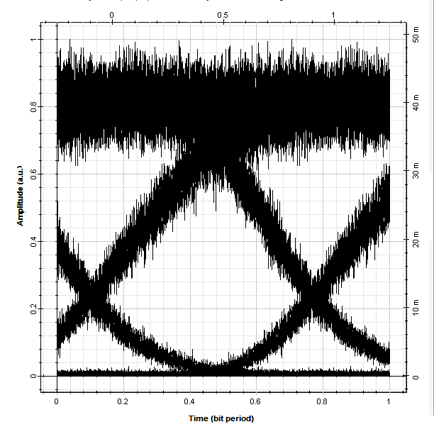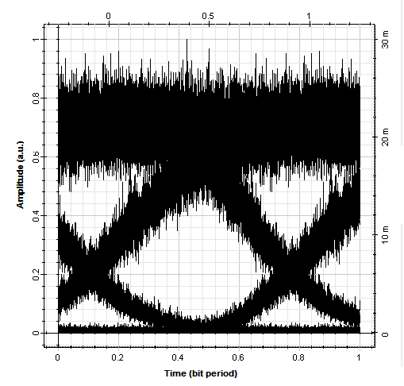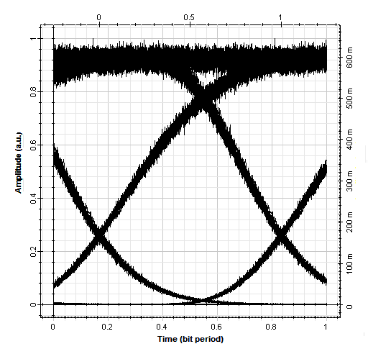

(a) (b) (c)

**Fig.6.** The received output eye diagram (1550 nm) at different nodes for foggy season.

During the rainy season, the droplet can lead to the irregularities like scattering and atmospheric attenuation which will decrease possibilities of the communication link range. In order to overcome the scattering and atmospheric attenuation due to the raindrops and increase the possibilities of FSO communication link range, the optical repeater or optical amplifier can be used. Fig. 7 describes the variation of Q-factor with respect to wavelength used. The performance of the proposed network during this season is better as compared to the other season. The reason behind is that due to the high attenuation (9.64 dB/km) of rainy season, the optical amplifier has been used after 1 km of FSO channel. The received output eye diagrams of node hav been shown in Fig. 8.

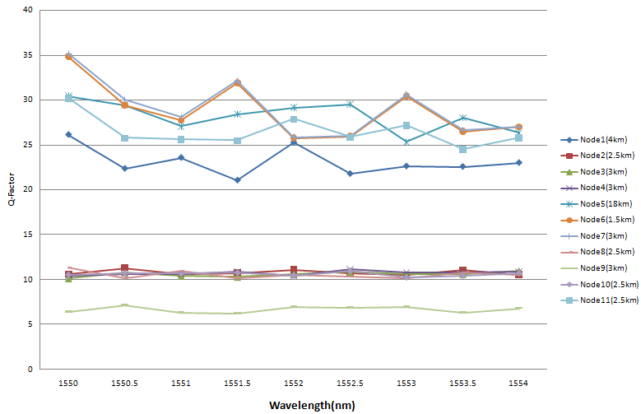

**Fig.7.** Graph of Q factor with respect to the used wavelengths at each node for rainy season.

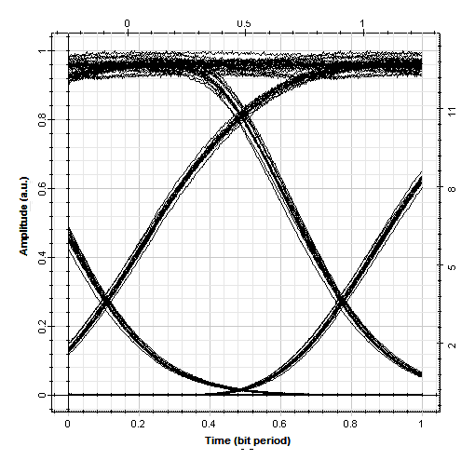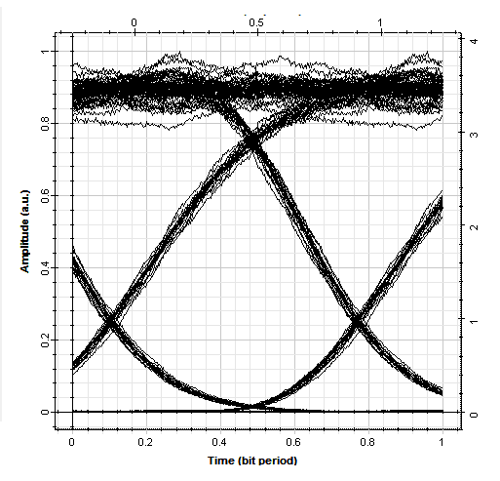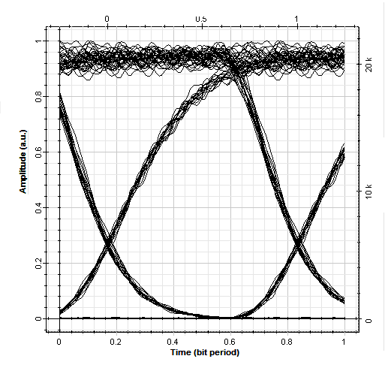

(a) (b) (c)

**Fig.8**. The received output eye diagram (1550 nm) at different nodes for rainy season.

1. **Conclusions**

In this work, an FSO communication network has been proposed throughout the Patiala and Rajpura region, Punjab, India. The weather conditions of this region have also been analyzed. The FSO communication link performance through all weather seasons of Patiala and Rajpura region has been observed. In all the weather seasons, the results at each node of the network have been calculated in terms of BER and Q-Factor. It has been concluded that in rainy season, there is a need of repeaters or amplifiers after every 1 km due to more attenuation than the other clear and foggy seasons. Further, it has been concluded that the rainy season output Q-Factor is better than other seasons.

**References:**

[1]. S. Singh, R.S. Kaler, “Comparison of Pre-, Post- and Symmetrical Compensation for 96 Channel DWDM System using PDCF and PSMF”, Optik, Vol. 124, pp. 1808– 1813, 2013.

[2]. V. W. S. Chan, “Free-space optical communications", Journal of Lightwave Technology, Vol. 24, no. 12, pp. 4750-4762, 2006.

[3]. Z. Ghassemlooy, S. Arnon, M. Uysal, Z. Xu, J. Cheng, “Emerging Optical Wireless Communications- Advances And Challenges”, IEEE Journal Select Areas Communication, Vol. 33, pp.1738–49, 2015.

[4]. Fsona Unveils 2-5-Gbps Free-Space Optical Systems, 2012.

[5]. J. Juarez, A. Dwivedi, A. Hammons, Jr., S. Jones, V. Weerackody, and R. Nichols, “Free-Space Optical Communications for Next-Generation Military Networks”, IEEE Communications Magazine, Vol. 44, no. 11, pp. 46–51, 2006.

[6]. A. Malik And P. Singh, “FSO: Current Applications And Future Challenges”, Hindawi Publishing Corporation, International Journal Of Optics, Vol. 2015, Article Id 945483, 7 Pages, 2015.

[7]. H. A. Fadhil, A. Amphawan, H. A. B. Shamsuddin, “Optimization Of FSO Parameters: An Optimum Solution For Bad Weather Conditions”, Optik, Vol. 124, No. 19, pp.3969–3973, 2013.

[8]. S. A. Al-Gailani, A. B. Mohammad, And R. Q. Shaddad, “Enhancement of FSO Link in Heavy Rain Attenuation Using Multiple Beam Concept”, Optik, Vol. 124, No. 21, pp. 4798–4801, 2013.

[9]. L. Wing, F. Ying, “Research on the Relationship of BER of FSO System with Beam Width in the Presence of the Beam Wander”, Journal of Opt. Opt-electron Technology, Vol. 8, pp. 26–30, 2010.

[10]. A. D. Kora, R. Hontinfinde, T. Ouattara, “FSO Attenuation Model For Visibilities Ranging From 9 To 12 Km”, The 10th International Conference On Future Networks And Communications (FNC 2015), Procedia Computer Science, Vol. 56, pp. 260 – 265, 2015**.**

[11]. S. Salamah, M. A. Alsubaie, M. J. Alnaser and O. Mahmoud, “Free Space Optical Communications Performance Under The Effect of Rain Attenuation in Canada”, International Journal of Engineering Research and Application, Vol. 6, no. 12, pp.64-68, 2016.

[12]. F. Rashidi, J. He, L. Chen, “Spectrum Slicing WDM For FSO Communication Systems under the Heavy Rain Weather”, Optics Communications, Vol. 387, pp. 296–302, 2017.

[13]. J. M. Senior, “Optical Fiber Communications”, Pearson Education, 3rd Edition, 2007.

[14]. Network Topology, Module 5, Broadcast Communication Networks, Version 2 CSE IIT, Kharagpur.